## PL/SQL program

set serveroutput on size 4000;

declare

address VARCHAR2(40);

street_number Number(10);

street_name VARCHAR2(60);

postal_code VARCHAR2(10);

blank_space Number(3);

today_date date;

begin

address := '&address';

blank_space := instr(address, ' ');

street_number := substr(address, 0, blank_space);

postal_code := trim(substr(address, -7));

street_name := substr(address, blank_space,

length(address) - blank_space - 7);

street_name := trim(street_name);

today_date := sysdate;

dbms_output.put_line('Today''s date With a given Format is ' ||

to_char(today_date,'DY, MONTH DD, YYYY HH24:MI:SS A.M.'));

dbms_output.put_line('Original Address is : ' || address);

dbms_output.put_line('The Street Number is : '

|| street_number);

dbms_output.put_line('The Street Name is : '

|| street_name);

dbms_output.put_line('The Postal Code is : '

|| postal_code);

end;

## Result

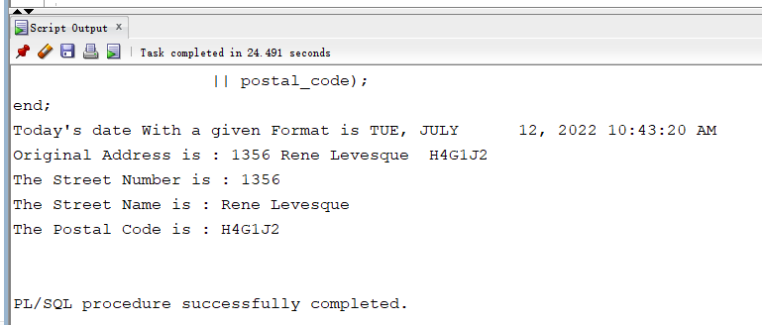

## Input address

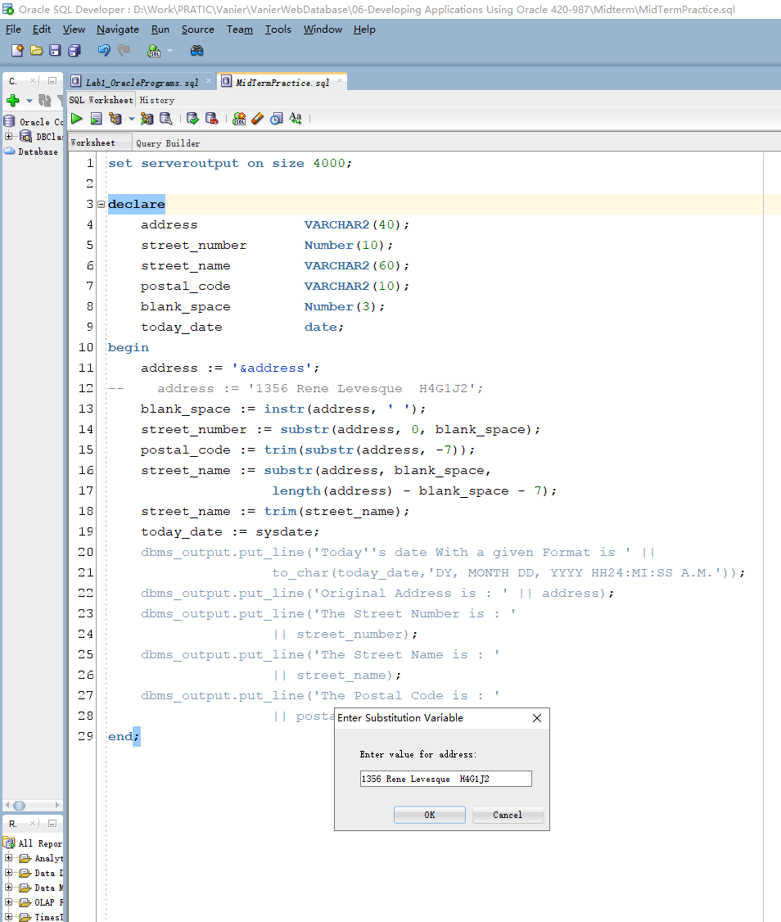

## Execution Screenshot

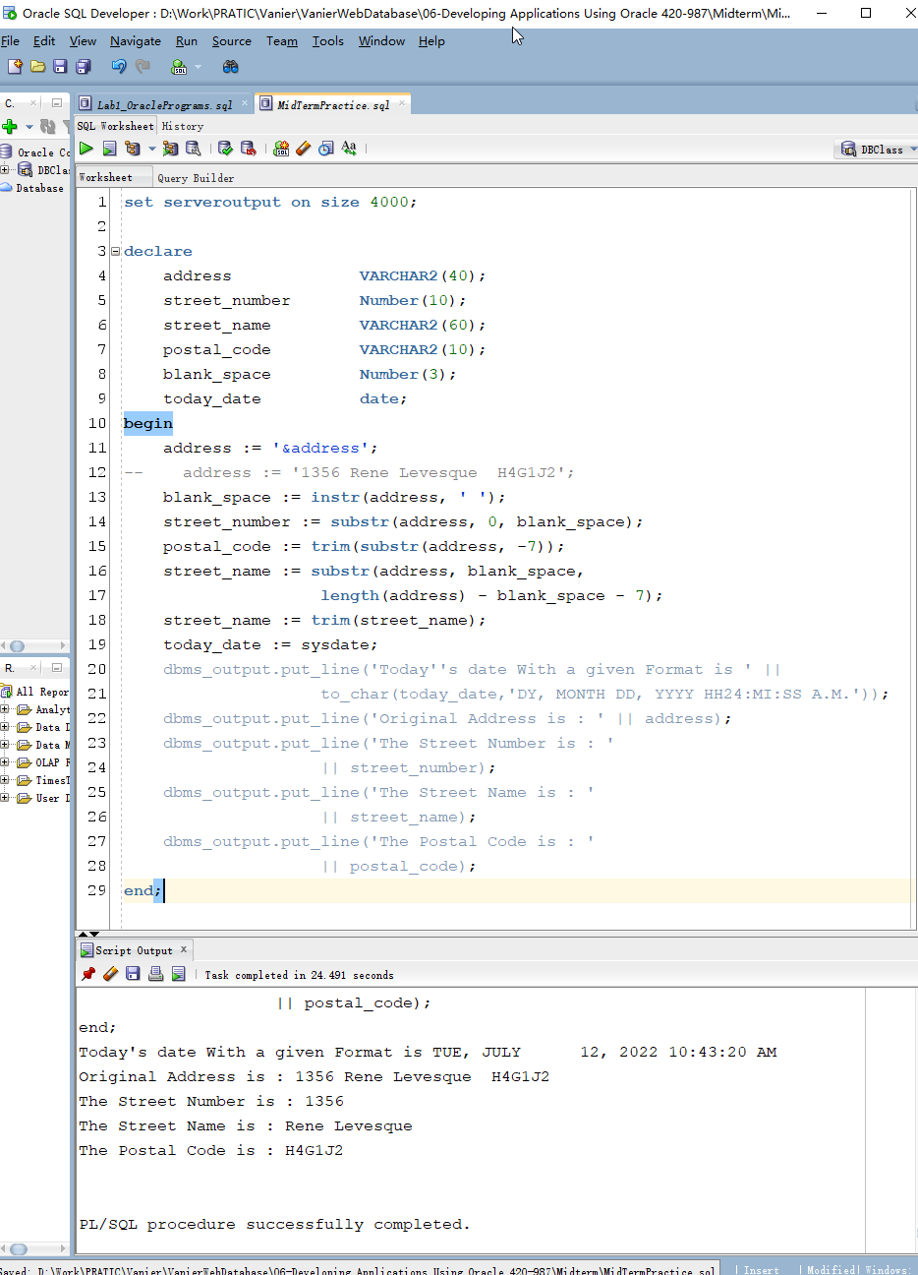

## Source Code Attachment

